**Event Handling:(13)**

Event handler in a function not a function call.do not add parentheses.

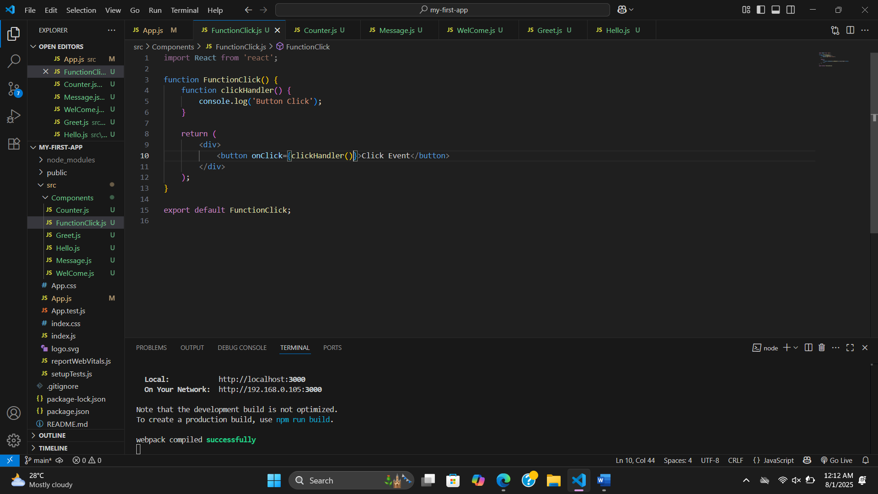

**Event Handling in Class component:**

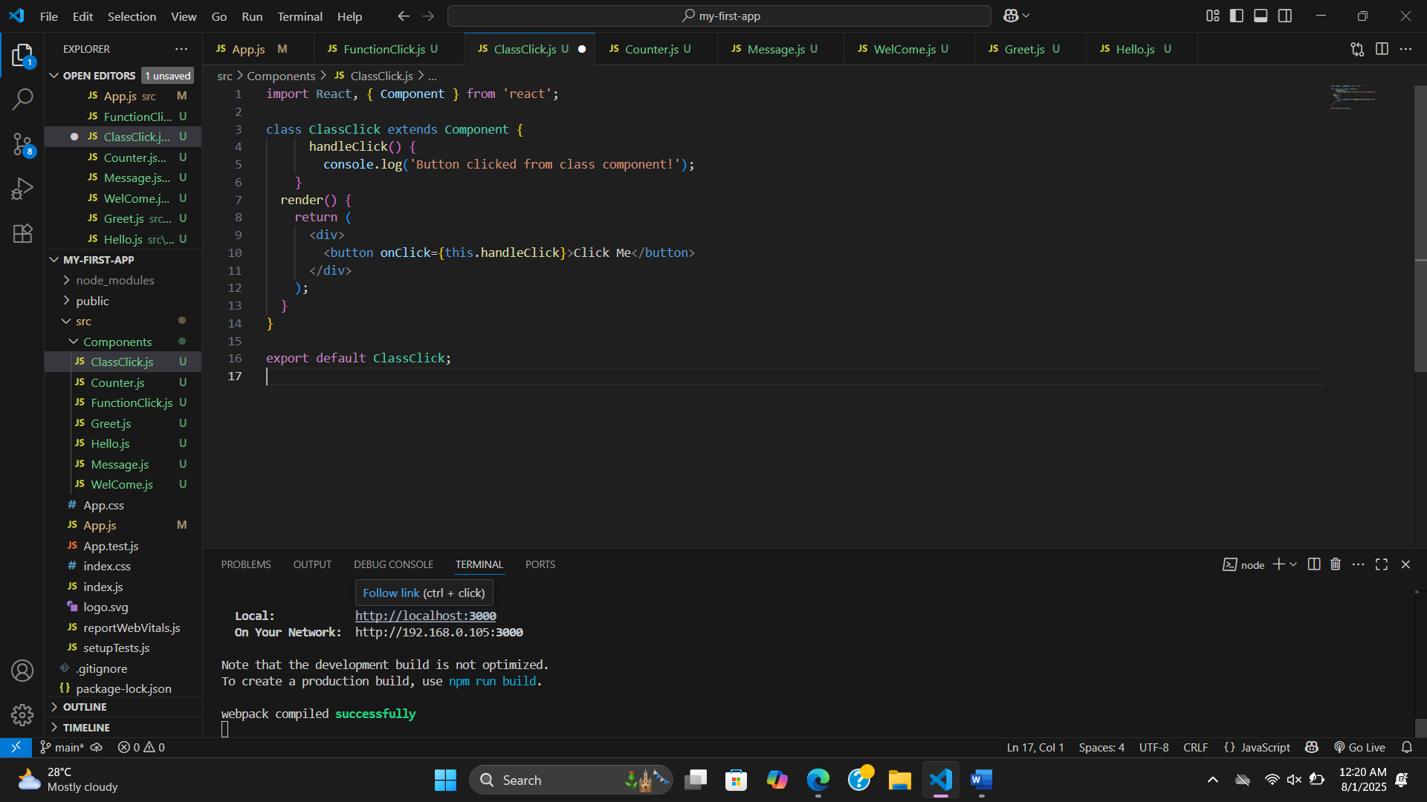

**Binding** **Event Handling:(14)**

1.Can use =>(**bind(this) on render method**

 render() {

    return (

      <div>

        <p>{this.state.message}</p>

        <button onClick={this.handleClick.bind(this)}>Click Event Bind</button>

      </div>

2. also can use => **(use arrow function)**

<button onClick={() => this.handleClick()}>Click Event Bind</button>

**3.mostly use (binding in the construstor):**

// Binding the method in the constructor

    this.handleClick = this.handleClick.bind(this);

